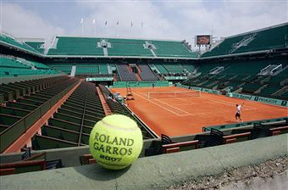
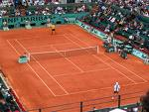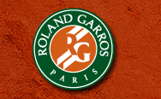

Popular 2009 French Open Finals Package
June 4th – June9th 2009
You will check-in Thursday June 4th for five nights and attend two day with category two tickets to Friday’s semi and Sunday’s finals
Right Bank: Hotel Novotel Paris Les Halles
(http://www.accorhotels.com/gb/hotel-0785-novotel-paris-les-halles/location.shtml)
Cost per person: $2688

West Bank: Odem Hotel
(http://www.paris-hotel-odeon.com/uk/galerie.htm)
Cost per couple: $2765

Options:

- Upgrade to lower level Category One tickets add $800 per person
- Paris cityrama tours
- Giverny - Monet's Gardens & home
- Pierre Cardin Fashion Show; 1950 to today
- Tours to Mt. St. Michel; Bordeaux; Normandy Luxury barge cruises
- Loire Valley Chateaux; Paris by night & more
- French Cooking School
- 2-day museum pass
- Private limo airport transfer
- Twilight Seine River Cruise

