Broach Golf Tours’ Most Popular Ireland Golf Adventures

- Southwest Ireland – Ireland most popular region – see seven (7) packages below
- Dublin and East Coast Links - includes 3 of the top 5 links golf courses by Golf Digest
- Northwest Coast Links - the best golf value in Ireland

Southwest Ireland
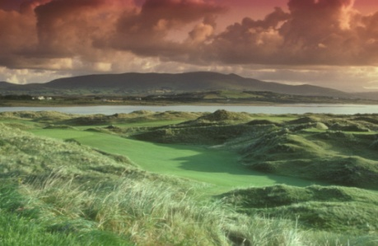
Day 1: Depart home for flight into Shannon, Ireland.

Day 2: Arrive next morning into Shannon Airport Ireland. You will be met by our Irish host who will present you with all your travel information and show you to either your rental car or will help your Irish driver/host load your luggage and clubs into your golf coach. You will travel to Ballybunion and play at the Cashen Course there, then after golf travel on to Killarney town, check into 4 Star Killarney Avenue Hotel (optional upgrade to The Killarney Plaza or Killarney Park Hotel) where you can relax and enjoy the lovely Irish town of Killarney.
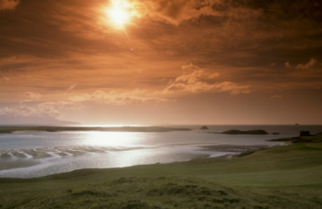
Day 3: Your golf today will be at Waterville Golf Links. Waterville Golf Links in Kerry is one of the finest links golf courses in the world, never mind Ireland. Located on the Ring of Kerry, the surrounding scenery and quality of golf holes is breathtaking to say the least. The front nine holes, which were designed to contrast with the more rugged and exposed, closing stretch, begin with the chillingly named "Last Easy."

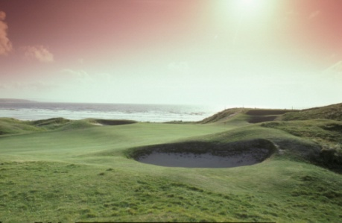
Day 4: Your golf today will be at Tralee Golf Club. Designed and built by Arnold Palmer, this stunning setting represents a true paradise for those willing to challenge what is widely acclaimed as one of the finest links courses in the world. Arnie said: "I may have designed the first nine, but surely God designed the back nine." Palmer chooses it to be his first and, arguably, his finest golf course in Europe.

Day 5: This morning after breakfast golf will be at the world famous Ballybunion Old Course. After playing Ballybunion for the first time, you would think that the game of golf originated there. Located on the Shannon estuary, it is a true seaside links course, virtually treeless and a course of sharp contours throughout. It looks like a course laid out on land back in the 10th century. It is a course that will test your

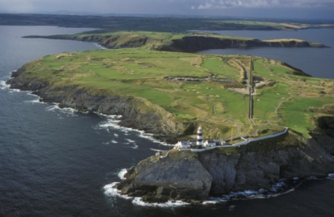
Day 6: After a full Irish Breakfast, your golf will be played at Old Head Kinsale. Old Head Golf Links is built on a 220-acre diamond of land, jutting out over two miles into the Atlantic Ocean. The promontory is almost an island with numerous caves running beneath your feet as you play the course. The links and practice area occupy 180 acres and the remaining 40 acres of unspoilt cliff (rising in places to over 300 feet) frame the course. After golf you will transfer 15 miles to lovely waterfront Irish town of Kinsale and will stay at the Kinsale Trident Hotel.

Day 7: After your last full Irish breakfast you will depart for home or extend your stay to play other Ireland courses or we have a wonderful Irish guide for local site seeing, history or archaeology adventures.

Your Southwest Ireland Golf Package includes:

- Five nights’ accommodations – four nights in Killarney and one night in Kinsale
- Full Irish breakfast each day.
- Greens fees and starting times for 5 rounds of golf at: Old Head, Ballybunion (Cashen), Waterville, Tralee, Ballybunion (Old)
- Rental vehicle with unlimited mileage, Collision Damage Waiver (CDW) and VAT tax or escorted tour with private vehicle and driver
- Broach Sports Tours Irish Golf travel guide
- Our local Irish host - you will love his knowledge of Ireland and all your options for golf and sightseeing
- Broach Sports Tours golf luggage tags and travel documents.
- All service charges and local taxes

Cost per person for Southwest Ireland Golf Tour

Self drive per person double occupancy: $2472

Escorted per person double occupancy: Group of 4: $2744; Group of 12: $2387

Single room supplement: Add $75 per person per night = $375 per person

Options and Add-ons:

Upgrade Accommodation in Killarney:

Killarney Plaza - very Nice 4* Deluxe - add $40 per person per night x 4 nights = $160
Killarney Park - 5* in Killarney- add $75 per person per night x 4 nights = $300

Upgrade Accommodations in Kinsale:

The Carlton - 4* - add $40 per person for the one night
Old Head Golf Club Suites – add $75 per person for the one night

Extend your stay - some options:

- Stay an extra night and play Old Head again: Add $195

- Stay an extra night and play Tralee again: Add $265

- Stay an extra day for local site seeing, history or archaeology: Add $150

Other courses in the area that you could substitute:

Killarney Killeen, Lahinch, Mahoney’s Point, Dooks, Ballybunion, Doonbeg

Air:

We will be glad to handle your air and golf bag transfers – cost will depend on dates and departure cities

April, 2011:

If you can travel in April, 2011 then deduct 5% from all the prices listed.

Availability is limited
Your itinerary is subject to availability at time of booking

Broach Sports Tours ■ 5821 Fairview Road #118 ■ Charlotte, NC 28209

1-800-849-6345

Contact our Golf Director, Carlos McCracken:
carlos@broachsportstours.com
Carlos’s direct line: 704-814-6801

If you would like to customize your own golf vacation with different courses, accommodations, dates

and/or itinerary, email our golf director Carlos McCracken at carlos@broachsportstours.com

or call him at his direct line: 704-814-6801
Dublin & East Coast Links

(includes 3 of top 5 golf courses in Ireland as rated by Golf Digest:
Royal Country Down, Baltray and Portmarnock – Old)

Day Golf Accommodations
1. Depart USA
2. Arrive Dublin Airport Play Portmarnock Links Portmarnock Links Hotel
3. Play Baltray (County Louth) Portmarnock Links Hotel
4. Play European Portmarnock Links Hotel
5. Play Royal County Down Portmarnock Links Hotel
6. Play Portmarnock (Old) Portmarnock Links Hotel
7. Depart Dublin Airport for USA

Cost per person Double Occupancy:

Self Drive Escorted Chauffeur Drive

Group of 4 $2385 $2588
Group of 10 $2145 $2166

Single Room Supplement: Add $75 per person per night

North West Coast Links
(Ireland’s very best value)

Day Golf Accommodations

1. Depart USA
2. Arrive Dublin Airport Portmarnock Links Portmarnock Links Hotel
3. Play Enniscrone Wyatt Hotel Westport
4. Play Strandhill Wyatt Hotel Westport
5. Play Carne Wyatt Hotel Westport
6. Play County Sligo Portmarnock Links Hotel
7. Depart Dublin for USA

Cost per person Double Occupancy:

Self Drive Escorted Chauffeur Drive

Group of 4 $1688 $2245

Group of 10 $1592 $1975

Single Room Supplement: Add $75 per person per night

Broach Sports Tours ■ 5821 Fairview Road #118 ■ Charlotte, NC 28209

1-800-849-6345

Contact our Golf Director, Carlos McCracken:
carlos@broachsportstours.com
Carlos’s direct line: 704-814-6801

One Week Value Southwest Coast Links.
( Starting at only $1588 per person)

Schedule:

Day Golf Accommodation
1. Depart USA
2. Arrive Shannon Airport Mahoney’s Point Killarney Guest House (3*)
3. Ballybunion (Cashen) Killarney Guest House (3*)
4. Tralee Killarney Guest House (3*)
5. Dooks Killarney Guest House (3*)
6. Tralee Killarney Guest House (3*)
7. Depart Shannon for USA

Prices PP double occupancy with full breakfast:

Self Drive: Escorted Chauffeur Drive:
Group of 4 $1750 $1945
Group of 6 $1695 $1950
Group of 8 $1695 $1850
Group of 10 $1625 $1788
Group of 12 $1588 $1695

Five Other Popular Southwest Ireland Golf Options

1. One Week Playing Southwest Coast Links
(Ireland’s most popular region)

Day Golf Accommodations

1. Depart USA
2. Arrive Shannon Airport Tralee Links Killarney Ave Hotel
3. Play Ballybunion (Cashen) Killarney Ave Hotel
4. Play Waterville Killarney Ave Hotel
5. Play Ballybunion (Old) Killarney Ave Hotel
6. Play Tralee Killarney Ave Hotel
7. Depart Shannon for USA

Cost per person Double Occupancy:

Self Drive Escorted Chauffeur Drive

Group of 4 $1975 $2435

Group of 10 $1796 $2245

Single Room Supplement: Add $75 per person per night

2. One-Week Playing Southwest & Doonbeg

Day Golf Accommodations

1. Depart USA
2. Arrive Shannon Airport Play Tralee Killarney Ave Hotel
3. Play Waterville Killarney Ave Hotel
4. Play Ballybunion (Old) Killarney Ave Hotel
5. Play Doonbeg O/N Golf Hotel Lahinch
6. Play Lahinch O/N Golf Hotel Lahinch
7. Depart Shannon for USA

Cost per person Double Occupancy:

Self Drive Escorted Chauffeur Drive

Group of 4 $2365 $2876

Single Room Supplement: Add $75 per person per night

3. One-Week Playing Southwest & Old Head
(includes Old Head for last 2 rounds)

Day Golf Accommodations
1. Depart USA
2. Arrive Shannon Airport Play Tralee Killarney Ave Hotel
3. Play Ballybunion (Old) Killarney Ave Hotel
4. Play Waterville Killarney Ave Hotel
5. Play Old Head Trident Hotel Kinsale
6. Play Old Head Trident Hotel Kinsale
7. Depart Shannon for USA

Cost per person Double Occupancy:

Self Drive Escorted Chauffeur Drive
Group of 4 $2365 $2876
Single Room Supplement: Add $75 per person per night

4. One Week Playing Southwest

Day Golf Accommodations
1. Depart USA
2. Arrive Shannon Airport Play Tralee Killarney Ave Hotel
3. Play Waterville Killarney Ave Hotel
4. Play Ballybunion (Old) Killarney Ave Hotel
5. Play Doonbeg O/N Golf Hotel Lahinch
6. Play Lahinch O/N Golf Hotel Lahinch
7. Depart Shannon for USA

Cost per person Double Occupancy:

Self Drive Escorted Chauffeur Drive
Group of 4 $2365 $2876
Single Room Supplement: Add $75 per person per night

5. One-Week Playing Southwest & Stay/Play Doonbeg.
(includes Old Head for last 2 rounds)

Day Golf Accommodation
1. Depart USA
2. Arrive Shannon Airport Play Tralee Killarney Ave Hotel
3. Play Waterville Killarney Ave Hotel
4. Play Ballybunion (Old) O/N Doonbeg Resort
5. Play Doonbeg O/N Doonbeg Resort
6. Play Lahinch O/N Doonbeg Resort
7. Depart Shannon for USA

Cost per person Double Occupancy:

Self Drive Escorted Chauffeur Drive

Group of 4 $2643 $2945

Group of 12 $2475 $2523

Single Room Supplement: Add $75 per person per night

Links Courses:
All of the golf courses featured here are genuine traditional seaside Links. Ireland boasts more seaside links courses than Scotland. In fact one third of all Seaside Links Courses are located in Ireland.

Golf Transportation

Getting around Ireland is relatively easy. Roads have been dramatically improved in recent years, though those in more off the beaten track locations are far from perfect, and golf courses are well sign-posted. For single golfers, couples or small groups we will arrange car rental or provide a chauffeur driven limousine. For larger groups we will provide a mini-bus or full size touring coach with driver.

Self drive: While we generally recommend that golfing groups, particularly first-time visitors, opt for a car or coach & driver, the self-drive option is often ideal for smaller groups of up to four golfers. Self-drive groups of more than four golfers will require two or more vehicles to maintain maximum comfort levels. A full range of vehicle sizes, both manual and automatic, is available throughout the year.

Escorted Drive: I deal for groups of all sizes, there is much to be said for choosing the chauffeur driven option and we generally recommend this to our clients. Whether using a car & driver or coach & driver, it means that you won't have to worry about directions, the legendary Irish roads or indulging in a post-round pint of Guinness. All of our drivers are very experienced and will become your best friend by the time you return home!

Helicopter Transfers: The hectic nature of some golf trips often requires faster transportation from place to place. Helicopter transport is ideal in this respect. Whether you wish play 18 holes at Waterville and Portrush in one day, or whether you just don't fancy a long journey, this option, although not inexpensive, is often the only answer.

Why Choose Escorted over Self Drive?: We strongly recommend the escorted option for your special Ireland Golf Vacation; there is just no comparison to this experience. Just think of having a friendly humorous Irish host taking care of your every need while you enjoy the comfort a of travelling in style in a 5* luxury motor coach while viewing fabulous scenery and concentrating on your game of golf, not to mention not having to worry about safety or getting lost (the roads are narrow and windy). Also you will be able to enjoy the great Irish Whiskeys and Guinness after a round of golf without worrying about driving. You will enjoy hearing the odd story, jokes and history and culture of the country. All our driver guides are qualified professionals; you will be treated to a feast of information on the Castles, Monasteries, Round Towers, Abbeys and Old ruins you will encounter as you travel through one of the world’s oldest civilisations.

Broach Sports Tours
5821 Fairview Road #118
Charlotte, NC 28209

1-800-849-6345

Availability is limited
Your itinerary is subject to availability at time of booking

If you would like to customize your own golf vacation including air with different courses, accommodations, dates

and/or itinerary, email us.

Contact our Golf Director, Carlos McCracken:
carlos@broachsportstours.com
Carlos’s direct line: 704-814-6801

